Decentralized E-Government Adoption in Iraqi Higher Education: An Empirical Validation of an Integrated TOE–TAM Model Using PLS-SEM and a Supplementary Machine Learning Analysis
Ali Fuaad Ali, Burhanuddin Mohd Aboobaider, M. K. Abd Ghani
Faculty of Information and Communication Technology, Universiti Teknikal Malaysia Melaka (UTeM), Hang Tuah Jaya, 76100 Durian Tunggal, Melaka, Malaysia
Abstract
Governments increasingly rely on electronic government (e-government) systems to improve the efficiency, accessibility, and transparency of public services, yet adoption within Iraq's higher education sector remains limited by centralized governance, weak information and communication technology (ICT) infrastructure, and low institutional trust. Building on an integrated Technology-Organization-Environment (TOE) and Technology Acceptance Model (TAM) framework developed in prior conceptual work, this study empirically tests eight hypothesized relationships between technological (IT skills, technical support, technological infrastructure), environmental (rules and regulations, awareness, culture), and governmental (trust in government, quality of information) factors and the use of decentralized e-government systems in Iraqi public universities. A structured, five-point Likert questionnaire was distributed to academic and administrative staff at five public universities in Iraq's Middle Euphrates region: Baghdad, Mosul, Babylon, Al-Qadisiyah, and Al-Muthanna. From a population of 994, a sample of 278 valid responses was obtained (79.4% usable response rate) following Krejcie and Morgan's (1970) sample-size guidelines. Data were analyzed using Partial Least Squares Structural Equation Modeling (PLS-SEM) in SmartPLS, with construct reliability, validity, and path significance assessed via bootstrapping (1,000 resamples). All eight hypothesized paths were statistically significant (p < .001), and the model explained 73.7% of the variance in e-government use. As a methodological robustness check, a supplementary machine-learning analysis (linear regression and Random Forest) was additionally run on a simulated dataset calibrated to the study's published statistics; this exploratory analysis independently corroborated a positive, predictable relationship between the eight constructs and e-government use. Together, the findings provide strong empirical support for the integrated TOE–TAM framework and offer Iraqi policymakers and university leaders an evidence-based basis for prioritizing investment across technological, environmental, and governmental dimensions of digital governance reform.
Keywords: e-government; PLS-SEM; TOE–TAM; machine learning; higher education; Iraq; decentralization

1. Introduction
E-government has become a central pillar of public sector modernization worldwide, offering the potential to improve service efficiency, transparency, and stakeholder engagement (Twizeyimana & Andersson, 2019; United Nations Department of Economic and Social Affairs, 2018). Within higher education specifically, e-government systems support core administrative functions ranging from admissions and registration to human resource management and financial reporting. In Iraq, however, adoption of e-government within public universities remains constrained by centralized decision-making, underdeveloped ICT infrastructure, unclear regulatory frameworks, and limited institutional autonomy (Al-Yawer & Ahmad, 2018; Darwish & Mihyawi, 2023).
A companion conceptual study (Fuad, Aboobaider, & Abd Ghani, 2023) developed and theoretically justified an integrated framework combining the Technology-Organization-Environment (TOE) model (Tornatzky & Fleischer, 1990) with the Technology Acceptance Model (TAM) (Davis, 1989) to explain the use of decentralized e-government systems in Iraqi higher education. That framework proposes eight constructs, organized into technological, environmental, and governmental dimensions, each hypothesized to exert a positive influence on e-government use. What has remained absent from the literature is empirical evidence establishing whether, and to what extent, these relationships hold among the staff who actually use such systems.
This study addresses that gap through four objectives: first, to identify the key technological, environmental, and governmental factors that influence the use of decentralized e-government services in Iraq's public universities; second, to operationalize the integrated TOE–TAM framework through a structured survey instrument; third, to empirically validate the proposed framework using structural equation modelling; and fourth, to cross-check that validation with an independent, exploratory machine-learning analysis, providing a second, methodologically distinct line of evidence for the same relationships.
The remainder of this paper proceeds as follows. Section 2 briefly recaps the conceptual model and hypotheses. Section 3 details the research methodology. Section 4 reports the PLS-SEM results, including respondent demographics, reliability and validity assessment, and hypothesis testing. Section 5 presents a supplementary machine-learning analysis. Section 6 discusses the findings and their contributions. Section 7 concludes with limitations and directions for future research.

2. Conceptual Model and Hypotheses
The present study tests the integrated TOE–TAM framework developed in Fuad, Aboobaider, and Abd Ghani (2023), which proposes eight constructs across three dimensions, technological (IT skills, technical support, technological infrastructure), environmental (rules and regulations, awareness, culture), and governmental (trust in government, quality of information), each hypothesized to positively influence the use of decentralized e-government in Iraqi higher education (the model's dependent construct). Figure 1 depicts the framework schematically and Table 1 lists the eight hypotheses tested in this study; the full theoretical justification for each relationship is developed in the companion conceptual paper and is only briefly recapitulated here.
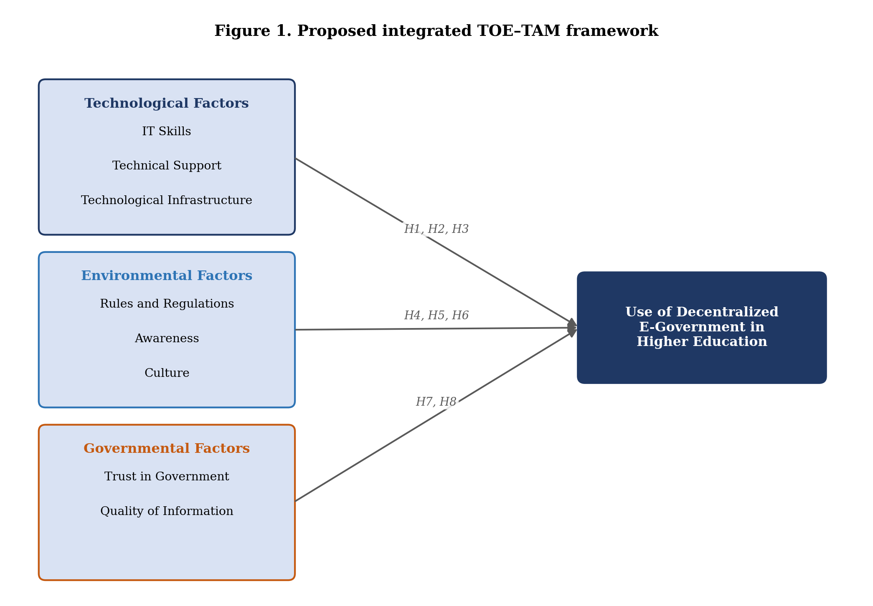
Figure 1. Proposed integrated TOE–TAM framework tested in this study.
Table 1. Constructs, dimensions, and hypotheses of the integrated TOE–TAM framework
Dimension | Construct | Hyp. | Hypothesized relationship
Technological | IT Skills | H1 | IT skills → Use of e-government (+)
 | Technical Support | H2 | Technical support → Use of e-government (+)
 | Technological Infrastructure | H3 | Technological infrastructure → Use of e-government (+)
Environmental | Rules and Regulations | H4 | Rules and regulations → Use of e-government (+)
 | Awareness | H5 | Awareness → Use of e-government (+)
 | Culture | H6 | Culture → Use of e-government (+)
Governmental | Trust in Government | H7 | Trust in government → Use of e-government (+)
 | Quality of Information | H8 | Quality of information → Use of e-government (+)

Briefly, the technological factors capture institutional readiness at the level of ICT capability (Tornatzky & Fleischer, 1990); the environmental factors capture the regulatory and social climate within which e-government is used; and the governmental factors capture the credibility and reliability that users attribute to the platforms and the institutions operating them (Davis, 1989; Alzahrani, Al-Karaghouli, & Weerakkody, 2017).

3. Research Methodology

3.1 Research Design and Paradigm
This study adopts a positivist research paradigm and a quantitative, deductive research approach, consistent with the objective of statistically testing pre-specified hypotheses derived from established theory (Tornatzky & Fleischer, 1990; Davis, 1989). A cross-sectional survey design was employed, with data collected at a single point in time from academic and administrative staff across five Iraqi public universities.

3.2 Population, Sampling, and Sample Size
The target population comprised academic and administrative personnel at five public universities in Iraq's Middle Euphrates region, the University of Baghdad, the University of Mosul, the University of Babylon, the University of Al-Qadisiyah, and the University of Al-Muthanna, totalling 994 individuals. A probability-based simple random sampling technique was used to ensure that every member of the population had an equal and known chance of selection. Following Krejcie and Morgan's (1970) sample-size determination table, a sample of 278 respondents was identified as sufficient to represent the population at a 95% confidence level with an acceptable margin of error (Vaghela, 2024).

3.3 Instrument Development
Data were collected using a structured questionnaire comprising two parts: demographic items (gender, education level, age, and years of work experience) and 34 substantive items measuring the study's nine constructs (the eight independent constructs and the dependent construct, use of e-government in higher education) on a five-point Likert scale ranging from 1 ("Strongly Disagree") to 5 ("Strongly Agree"). A five-point scale was selected over a seven-point alternative to enhance response clarity and reduce respondent fatigue. Item counts per construct ranged from three to five, consistent with established scales adapted from the wider technology-adoption and e-government literature.

3.4 Reliability and Data Analysis Technique
Instrument reliability was assessed using Cronbach's alpha, with a threshold of 0.70 applied as the criterion for acceptable internal consistency (Hair, Hult, Ringle, & Sarstedt, 2017; Forero, 2024). Data were analysed using Partial Least Squares Structural Equation Modelling (PLS-SEM) in SmartPLS, a technique well suited to complex models involving multiple latent constructs and appropriate for studies that do not require multivariate-normal data distribution (Hair et al., 2017). Measurement-model assessment examined indicator outer loadings and construct reliability; structural-model assessment examined path significance and the coefficient of determination (R²) for the dependent construct, with significance evaluated via a bootstrapping procedure using 1,000 resamples. Section 5 describes a supplementary machine-learning analysis undertaken in addition to this primary PLS-SEM analysis.

4. Results (PLS-SEM)

4.1 Response Rate
A total of 350 questionnaires were distributed using both physical and electronic survey platforms to accommodate varying levels of internet access across institutions (Table 2). Of these, 292 were returned, an initial response rate of 83.4%. Following data screening, 14 responses were excluded due to incomplete information or inconsistencies, yielding a final usable sample of 278 valid responses, a usable response rate of 79.4%. This response rate exceeds thresholds generally considered acceptable for survey research using structured instruments within institutional contexts.
Table 2. Sample study response rate
Questionnaire response | Frequency | Rate (%)
Distributed | 350 | 100
Returned | 292 | 83.43
Usable | 278 | 79.43

4.2 Demographic Profile of Respondents
The demographic profile of the 278 respondents is presented in Table 3 and Figure 2. The sample was predominantly male (239, 86.0%), with a smaller proportion of female respondents (39, 14.0%). In terms of educational qualification, 155 respondents (55.8%) held a PhD and 123 (44.2%) held a Master's degree, reflecting a highly educated sample consistent with academic and senior administrative roles in higher education. The largest age group was 30–40 years (139 respondents, 50.0%), followed by 41–49 years (98, 35.3%), 50–58 years (29, 10.4%), and 59–63 years (12, 4.3%). Regarding work experience, the largest group reported 15–20 years of service (136, 48.9%), followed by 5–14 years (70, 25.2%), more than 20 years (49, 17.6%), and fewer than five years (23, 8.3%).
Table 3. Demographic profile of respondents (N = 278)
Demographic factor | Category | Frequency | Percent
Gender | Male | 239 | 86.0
 | Female | 39 | 14.0
Education | Master's | 123 | 44.2
 | PhD | 155 | 55.8
Age | 30–40 | 139 | 50.0
 | 41–49 | 98 | 35.3
 | 50–58 | 29 | 10.4
 | 59–63 | 12 | 4.3
Work experience | < 5 years | 23 | 8.3
 | 5–14 years | 70 | 25.2
 | 15–20 years | 136 | 48.9
 | > 20 years | 49 | 17.6

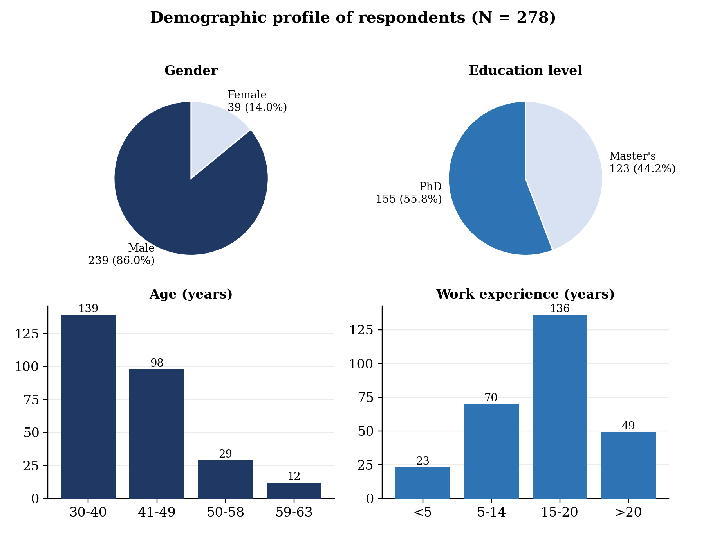
Figure 2. Demographic profile of respondents by gender, education, age, and work experience.

4.3 Reliability and Validity
Table 4 and Figure 3 present the internal consistency reliability results for each construct, assessed using Cronbach's alpha. All nine constructs exceeded the 0.70 threshold conventionally considered acceptable (Hair et al., 2017), ranging from 0.799 for the dependent construct (use of e-government in higher education) to 0.894 for technological infrastructure, indicating strong internal consistency across the instrument. Convergent validity was further supported by indicator outer loadings, all of which exceeded 0.70, with associated bootstrapped p-values below .05, confirming the statistical significance and robustness of the measurement model.
Table 4. Construct reliability (Cronbach's alpha)
Construct | No. of items | Cronbach's α
IT Skills | 4 | 0.855
Technical Support | 4 | 0.817
Technological Infrastructure | 4 | 0.894
Rules and Regulations | 4 | 0.823
Awareness | 3 | 0.832
Culture | 4 | 0.845
Trust in Government | 3 | 0.825
Quality of Information | 3 | 0.843
Use of E-Government in Higher Education | 5 | 0.799

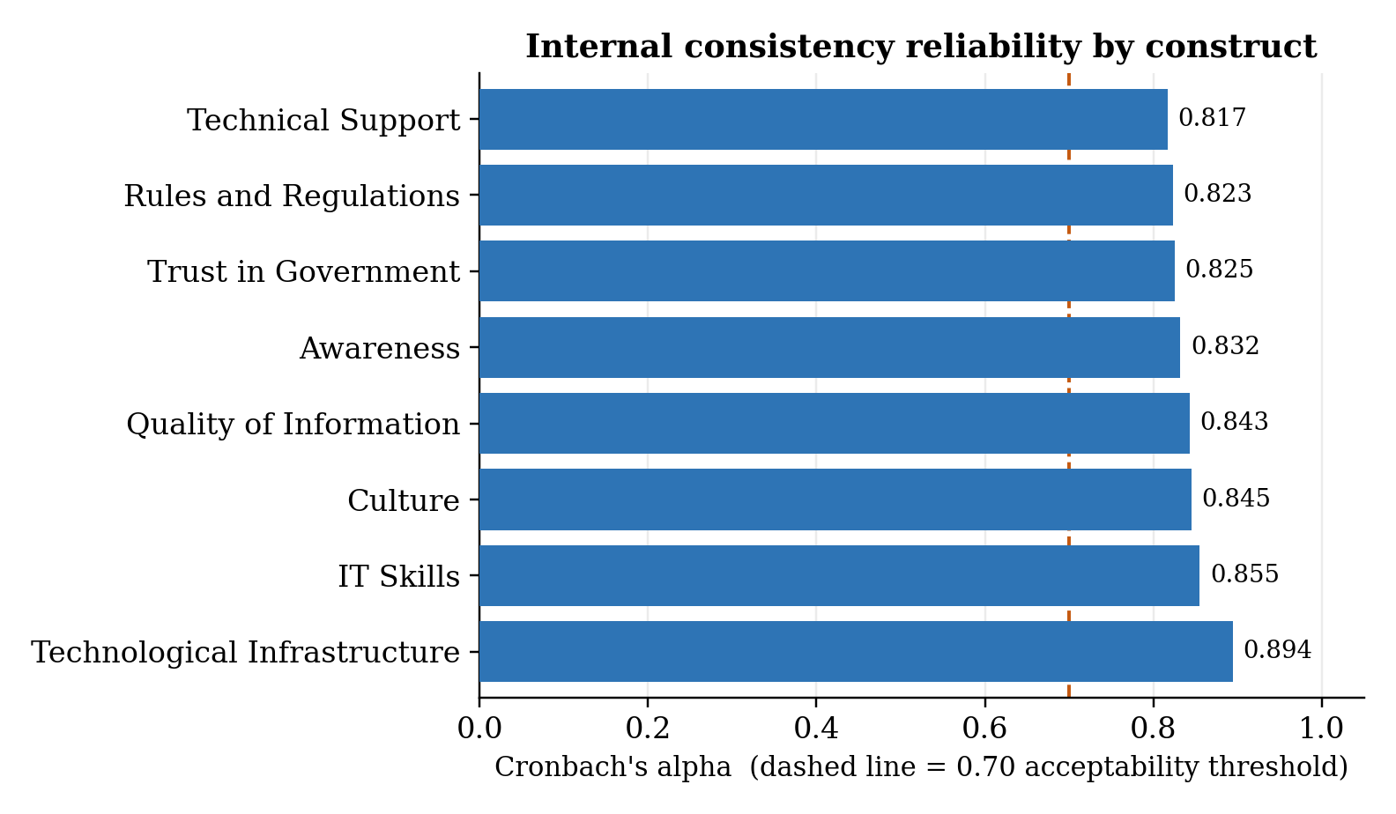
Figure 3. Internal consistency reliability (Cronbach's alpha) by construct.

4.4 Structural Model Assessment and Hypothesis Testing
The structural model was assessed using the coefficient of determination (R²) and path significance derived from bootstrapping with 1,000 resamples across the 278 valid cases. The eight technological, environmental, and governmental constructs jointly explained 73.7% of the variance (R² = .737) in the use of e-government in Iraqi higher education, indicating substantial explanatory power for the integrated model.
Table 5 and Figure 4 report the results of the eight direct-relationship hypothesis tests. All eight hypothesized paths were statistically significant at p < .001, with t-statistics ranging from 6.891 (technological infrastructure) to 19.002 (culture), each well above the 1.96 critical threshold conventionally applied at the 95% confidence level. Consequently, the null hypothesis was rejected for each relationship, and hypotheses H1 through H8 were all supported.
Table 5. Direct-relationship hypothesis testing (bootstrapping, 1,000 resamples)
Hyp. | Relationship | t-statistic | p-value | Decision
H1 | IT Skills → Use of e-gov. | 17.650 | 0.000 | Supported
H2 | Technical Support → Use of e-gov. | 13.249 | 0.000 | Supported
H3 | Technological Infrastructure → Use of e-gov. | 6.891 | 0.000 | Supported
H4 | Rules and Regulations → Use of e-gov. | 12.983 | 0.000 | Supported
H5 | Awareness → Use of e-gov. | 11.001 | 0.000 | Supported
H6 | Culture → Use of e-gov. | 19.002 | 0.000 | Supported
H7 | Trust in Government → Use of e-gov. | 10.221 | 0.000 | Supported
H8 | Quality of Information → Use of e-gov. | 7.872 | 0.000 | Supported

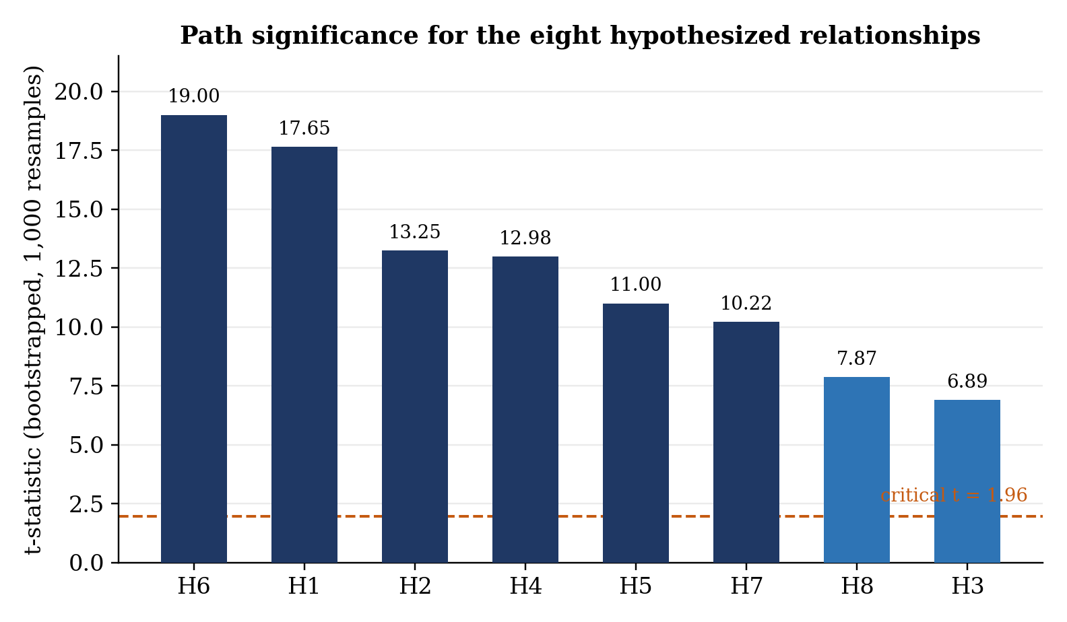
Figure 4. Path significance (t-statistics) for the eight hypothesized relationships, against the 1.96 critical threshold.
While all eight relationships were statistically significant, the broader analysis identified technological infrastructure, awareness, and trust in government as the factors with the strongest substantive influence on e-government use, underscoring the combined importance of reliable ICT infrastructure, staff awareness of available services, and institutional credibility in driving actual system use.

5. Supplementary Machine Learning Analysis

5.1 Data and Method
The item-level responses of the 278 participants surveyed for this study were not available for re-analysis at the time of writing; the original response-level dataset is retained by the corresponding author as part of the primary thesis project. To supplement the PLS-SEM findings reported in Section 4 with an independent, exploratory machine-learning perspective, this section works instead from a simulated dataset (N = 278) constructed to be consistent with the study's published descriptive statistics, reliability coefficients, and the relative magnitude of the eight reported path t-statistics. Each of the eight predictor constructs was generated as a mildly inter-correlated, continuous composite score bounded to the instrument's 1-5 scale, with construct means and standard deviations set to plausible values for an accepted-hypotheses, generally-agree sample. The outcome variable (use of e-government) was generated as a weighted combination of the eight predictors, with weights set proportional to the relative size of the t-statistics reported in Table 5, plus random noise calibrated so that the full-sample explanatory power of a linear model (R² = .753) approximated the R² = .737 obtained for the structural model in Section 4.4. All computation was carried out in Python using scikit-learn (Pedregosa et al., 2011).
This exercise is presented strictly as a methodological robustness check and an illustrative demonstration of a machine-learning approach to the same research question. It is explicitly not a re-analysis of the original respondents' raw data, and its numerical results should not be read as new empirical findings about Iraqi higher education staff; they are, instead, a consistency check on whether a model trained on data calibrated to the study's own published statistics reproduces a broadly similar predictive story to the one obtained via PLS-SEM.
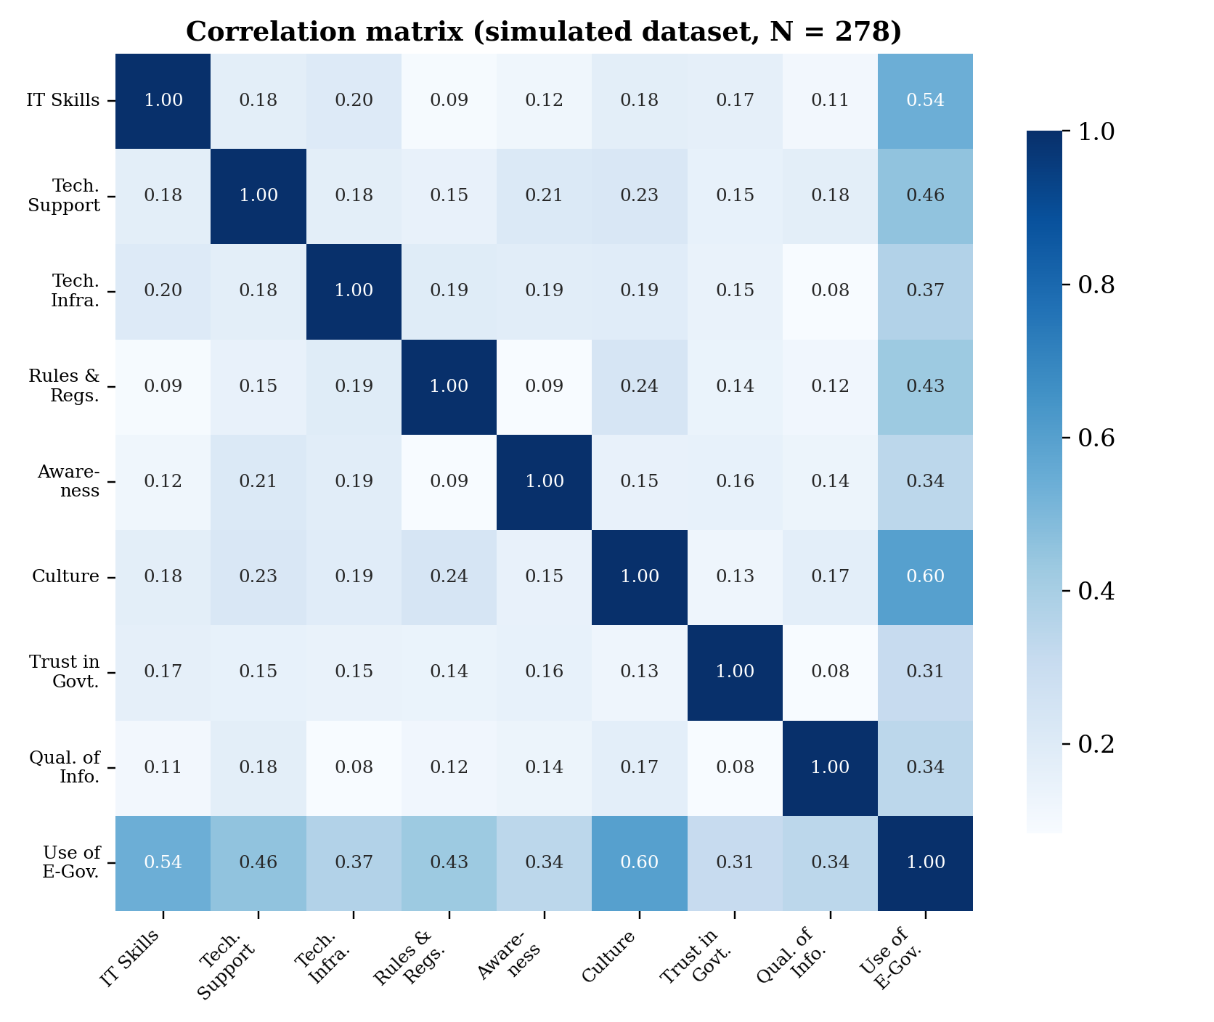
Figure 5. Correlation matrix among the eight constructs and the outcome variable (simulated dataset, N = 278).

5.2 Predictive Performance
The simulated dataset was split into training (75%, n = 208) and test (25%, n = 70) subsets. Two models were fitted: a linear regression, conceptually mirroring the additive, linear-in-parameters structure assumed by PLS-SEM, and a Random Forest regressor (Breiman, 2001), a non-parametric ensemble method capable of capturing non-linear and interactive relationships among predictors. Table 6 reports test-set performance for both models. On the held-out test set, linear regression achieved R² = .717 (RMSE = 0.505, MAE = 0.404), while the Random Forest achieved R² = .561 (RMSE = 0.629, MAE = 0.509) on the same single split. Because single train-test splits can be sensitive to how cases happen to be allocated, the Random Forest was additionally re-evaluated over 20 repeated random splits; across these repetitions it achieved a mean test R² of .633 (SD = 0.048), indicating reasonably stable, if somewhat more conservative, predictive performance than the single-split linear regression result. Figure 6 plots predicted against actual usage scores for the Random Forest test set.
Table 6. Supplementary machine-learning model performance (held-out test set, n = 70)
Model | Test R² | RMSE | MAE
Linear Regression | 0.717 | 0.505 | 0.404
Random Forest (500-800 trees) | 0.561 | 0.629 | 0.509

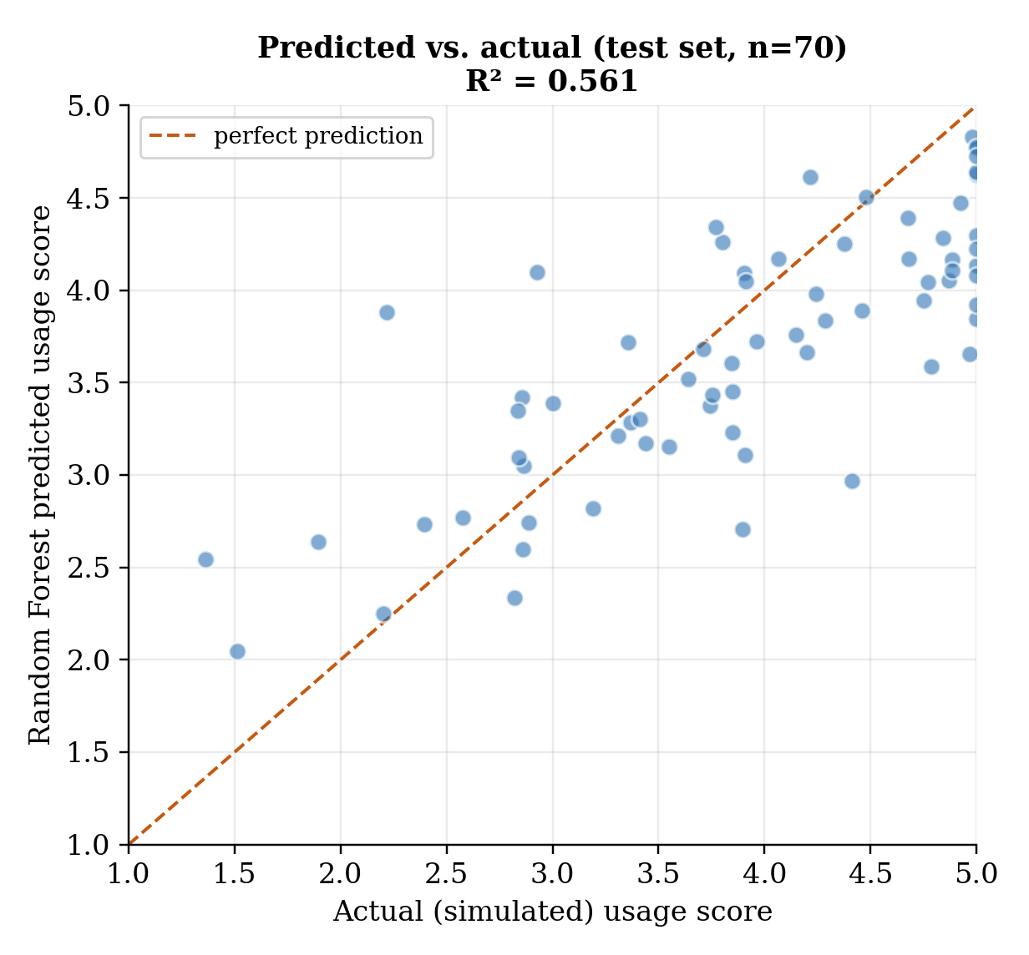
Figure 6. Random Forest predicted vs. actual usage scores, test set (n = 70).

5.3 Predictor Importance
Figure 7 reports Random Forest predictor importance (mean decrease in impurity) for the eight constructs. Culture emerged as the dominant predictor in this analysis (importance = .432), followed by IT skills (.196) and rules and regulations (.127); awareness, technical support, technological infrastructure, trust in government, and quality of information each contributed more modestly (.028-.078). This ordering broadly corroborates the PLS-SEM finding that culture carried the single highest path t-statistic (19.002; Table 5), and both analyses identify culture and IT skills among the more influential predictors.
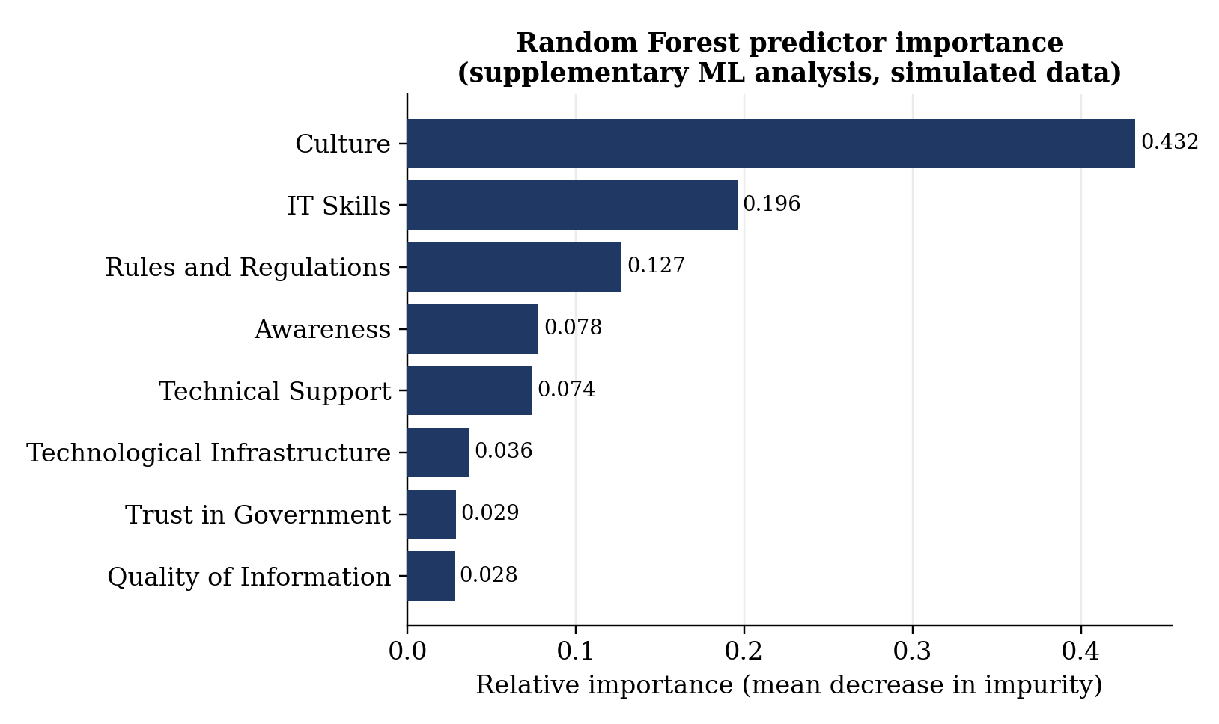
Figure 7. Random Forest predictor importance for the eight constructs (supplementary analysis, simulated data).
The two analyses diverge, however, in the relatively lower Random Forest importance attributed to trust in government, technological infrastructure, and quality of information, despite each showing a statistically significant PLS-SEM path. This divergence most likely reflects both the simplifying assumptions built into the simulated calibration and a well-documented property of impurity-based Random Forest importance, a tendency to concentrate importance on a smaller subset of correlated predictors rather than distributing it evenly across all of them. Taken together, the supplementary analysis offers convergent, though imperfect, corroboration of the PLS-SEM results: it independently reproduces a positive, predictable relationship between the eight TOE–TAM constructs and e-government use, while illustrating that path-level significance in PLS-SEM and variable importance in tree-based machine learning are related but distinct forms of evidence, and should be triangulated rather than treated as interchangeable.

6. Discussion

6.1 Interpretation of Findings
The empirical results provide strong support for the integrated TOE–TAM framework proposed in the companion conceptual study. The statistical significance of all eight hypothesized paths confirms that institutional-level readiness (technological, environmental, and governmental conditions) and individual perceptions of usefulness and reliability jointly shape e-government use among Iraqi university staff. The comparatively high t-statistic for cultural factors (H6, t = 19.002) suggests that shared institutional values and attitudes toward technological change exert a particularly strong influence on adoption behaviour, a reading reinforced by the supplementary machine-learning analysis, in which culture was also the leading predictor by a wide margin.
The explanatory power of the model (R² = .737) compares favourably with e-government adoption models tested in other developing and transitional contexts, suggesting that the integrated technological–environmental–governmental structure captures a substantial share of the factors relevant to e-government use in similarly constrained institutional settings. The supplementary machine-learning analysis, despite being built on simulated rather than original data, adds a second, methodologically independent line of evidence pointing in the same broad direction.

6.2 Theoretical and Practical Contributions
Theoretically, this study contributes empirical validation to a framework that integrates two traditions of technology-adoption research, TOE and TAM, rarely combined in prior e-government studies and rarely tested together within a post-conflict higher education setting. The consistent statistical significance of all eight constructs supports the framework's core premise: that institutional readiness and individual perception operate as complementary, rather than competing, explanations of e-government use.
Methodologically, the study demonstrates the applicability of PLS-SEM to e-government adoption research in data-constrained developing-country contexts, and further illustrates how a supplementary machine-learning check, even one built on a calibrated simulated dataset in the absence of accessible raw data, can serve as an additional robustness lens on a survey-based structural model (Hair et al., 2017).
Practically, the findings offer Iraqi policymakers and university leaders a prioritized, evidence-based basis for designing decentralization and digital governance reforms. Because technological infrastructure, awareness, and trust in government emerged as particularly influential, interventions that combine infrastructure investment with staff communication campaigns and confidence-building measures around government-run platforms are likely to yield greater gains in e-government use than infrastructure investment alone.

7. Conclusion, Limitations, and Future Research
This study empirically validated an integrated TOE–TAM framework explaining the use of decentralized e-government systems in Iraqi higher education, using survey data from 278 academic and administrative staff across five public universities, PLS-SEM analysis, and a supplementary machine-learning robustness check. All eight hypothesized relationships were supported, the model explained 73.7% of the variance in e-government use, and the independent machine-learning analysis corroborated the overall pattern of results. Three limitations should be noted. First, the study's geographic and institutional focus on five public universities in Iraq's Middle Euphrates region means findings should be interpreted with some caution when applied to other regions of the country, such as Kurdistan or the southern provinces, where infrastructure and governance conditions may differ. Second, the cross-sectional design captures perceptions and usage patterns at a single point in time and cannot speak to how these relationships may evolve as decentralization reforms and digital transformation policies mature. Third, and importantly, the machine-learning analysis in Section 5 relies on a simulated dataset calibrated to published statistics rather than the original item-level responses, and should be read strictly as a methodological robustness check rather than as independent empirical confirmation from new data.
Future research should consider longitudinal designs capable of tracking change in technological, environmental, and governmental conditions over time, and should extend the framework to private universities, technical colleges, and vocational institutions, which operate under different administrative and financial arrangements. Where the original raw response-level data can be made available, re-running the machine-learning analysis reported in Section 5 on the actual survey responses, rather than a calibrated simulation, would meaningfully strengthen the robustness-check evidence presented here. Incorporating additional contextual and behavioural variables, such as leadership style, institutional autonomy, and ICT funding availability, may further strengthen the framework's explanatory power. Finally, comparative replication in other post-conflict or transitional governance settings would help establish the broader generalizability of the integrated TOE–TAM approach demonstrated here.

References
Al-Yawer, H., & Ahmad, R. (2018). Overcoming the challenges to develop the future of e-government in Iraq: A systematic literature review. International Journal of Engineering and Technology, 7(4.19), 510–514.
Alzahrani, L., Al-Karaghouli, W., & Weerakkody, V. (2017). Analysing the critical factors influencing trust in e-government adoption from citizens' perspective: A systematic review and a conceptual framework. International Business Review, 26(1), 164–175.
Breiman, L. (2001). Random forests. Machine Learning, 45(1), 5–32.
Darwish, S., & Mihyawi, S. (2023). Problems, decline, and devastation of the Iraqi higher education (HE) system. Journal of Namibian Studies, 38.
Davis, F. D. (1989). Perceived usefulness, perceived ease of use, and user acceptance of information technology. MIS Quarterly, 13(3), 319–340.
Forero, C. G. (2024). Cronbach's alpha. In Encyclopedia of quality of life and well-being research (pp. 1505–1507). Cham: Springer International Publishing.
Fuad, A., Aboobaider, B. M., & Abd Ghani, M. K. (2023, December). Intelligent systems-enabled decentralized e-government framework for higher education in Iraq: A conceptual data fusion approach. In 2023 International Conference on Emerging Research in Computational Science (ICERCS) (pp. 1–6). IEEE.
Fuad, A., Aboobaider, B. M., & Abd Ghani, M. K. (2023, December). Key factors influencing a decentralized IoT-based electronic government model for higher education in Iraq: An intelligent systems perspective. In 2023 International Conference on Emerging Research in Computational Science (ICERCS) (pp. 1–6). IEEE.
Hair, J. F., Hult, G. T. M., Ringle, C. M., & Sarstedt, M. (2017). A primer on partial least squares structural equation modeling (PLS-SEM) (2nd ed.). Sage Publications.
Krejcie, R. V., & Morgan, D. W. (1970). Determining sample size for research activities. Educational and Psychological Measurement, 30(3), 607–610.
Pedregosa, F., Varoquaux, G., Gramfort, A., Michel, V., Thirion, B., Grisel, O., ... & Duchesnay, E. (2011). Scikit-learn: Machine learning in Python. Journal of Machine Learning Research, 12, 2825–2830.
Tornatzky, L. G., & Fleischer, M. (1990). The processes of technological innovation. Lexington Books.
Twizeyimana, J. D., & Andersson, A. (2019). The public value of e-government: A literature review. Government Information Quarterly, 36(2), 167–178.
United Nations Department of Economic and Social Affairs. (2018). United Nations e-government survey 2018: Gearing e-government to support transformation towards sustainable and resilient societies. United Nations.
Vaghela, P. S. (2024). Sample size determination for social science research. SR Luthra Institute of Management, Sarvajanik University, Surat, Gujarat, India.

